ReactJS Hands-on 18
Title: Unit Testing React Components using Enzyme and Jest

Project Structure
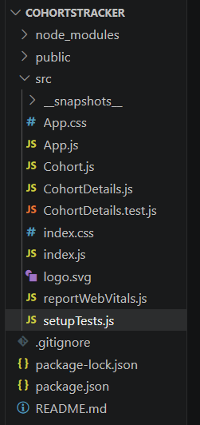

Step 1: Install Dependencies
npm install
npm install --save-dev enzyme enzyme-adapter-react-16 react-test-renderer@16.14.0 --legacy-peer-deps

package.json (devDependencies)
{
"devDependencies": {
"enzyme": "^3.11.0",
"enzyme-adapter-react-16": "^1.15.8",
"react-test-renderer": "^16.14.0"
}
}

setupTests.js
import '@testing-library/jest-dom';
import { configure } from 'enzyme';
import Adapter from 'enzyme-adapter-react-16';
configure({
adapter: new Adapter(),
});

Cohort.js
class Cohort {
constructor(cohortCode,startDate,technology,trainerName,coachName,currentStatus){
this.cohortCode=cohortCode;
this.coachName=coachName;
this.trainerName=trainerName;
this.technology=technology;
this.startDate=startDate;
this.currentStatus=currentStatus;
}
}
const CohortsData=[
new Cohort('INTADMDF10','22-Feb-2022','.NET FSD','Jojo Jose','Aathma','Scheduled'),
new Cohort('ADM21JF014','10-Sep-2021','Java FSD','Elisa Smith','Apoorv','Ongoing'),
new Cohort('CDBJF21025','24-Dec-2021','Java FSD','John Doe','Aathma','Ongoing'),
new Cohort('INTADMJF12','22-Feb-2022','Java FSD','To Be Assigned','Ibrahim','Scheduled'),
new Cohort('CDE22JF011','24-Dec-2021','Java FSD','Emma Swan','Apoorv','Ongoing'),
new Cohort('INTADMDF09','22-Feb-2022','Dataware Housing','Babjee Rao','Aathma','Scheduled'),
new Cohort('ADM22DF001','10-Sep-2021','.NET FSD','Marie Curie','Ibrahim','Ongoing')
];
export {Cohort,CohortsData};

CohortDetails.js
function CohortDetails(props){
return(
<div>
<h3>{props.cohort.cohortCode} -
<span>{props.cohort.technology}</span></h3>
<dl>
<dt>Started On</dt>
<dd>{props.cohort.startDate}</dd>
<dt>Current Status</dt>
<dd>{props.cohort.currentStatus}</dd>
<dt>Coach</dt>
<dd>{props.cohort.coachName}</dd>
<dt>Trainer</dt>
<dd>{props.cohort.trainerName}</dd>
</dl>
</div>
);
}
export default CohortDetails;

CohortDetails.test.js
import { shallow } from 'enzyme';
import renderer from 'react-test-renderer';
import CohortDetails from './CohortDetails';
import { CohortsData } from './Cohort';
describe('Cohort Details Component',()=>{
it('should create the component',()=>{
const wrapper=shallow(<CohortDetails cohort={CohortsData[0]}/>);
expect(wrapper.exists()).toBe(true);
});
it('should initialize the props',()=>{
const wrapper=shallow(<CohortDetails cohort={CohortsData[0]}/>);
expect(wrapper.instance).toBeTruthy;
});
it('should display cohort code in h3',()=>{
const wrapper=shallow(<CohortDetails cohort={CohortsData[0]}/>);
expect(wrapper.find('h3').text()).toContain(CohortsData[0].cohortCode);
});
it('should always render same html',()=>{
const tree=renderer.create(<CohortDetails cohort={CohortsData[0]}/>).toJSON();
expect(tree).toMatchSnapshot();
});
});

Snapshot file
// Jest Snapshot v1, https://goo.gl/fbAQLP
exports[`Cohort Details Component should always render same html 1`] = `
<div>
<h3>
INTADMDF10
-
<span>
.NET FSD
</span>
</h3>
<dl>
<dt>
Started On
</dt>
<dd>
22-Feb-2022
</dd>
<dt>
Current Status
</dt>
<dd>
Scheduled
</dd>
<dt>
Coach
</dt>
<dd>
Aathma
</dd>
<dt>
Trainer
</dt>
<dd>
Jojo Jose
</dd>
</dl>
</div>
`;

Run Tests
npm test

Output
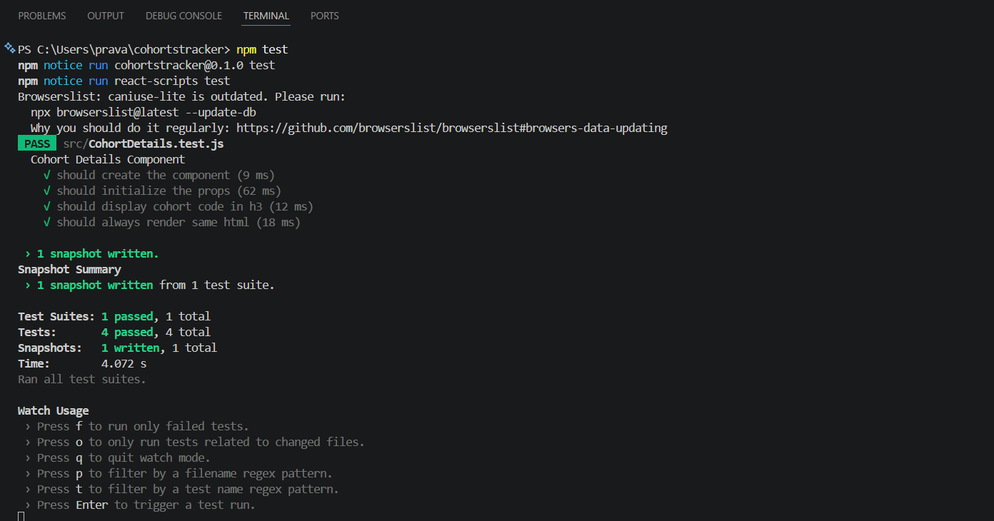

Conclusion
The CohortDetails React component was successfully tested using Jest and Enzyme. All four test cases passed and the snapshot test was generated successfully.

